3.1 & 3.2 The Derivative Function Worksheet

- Suppose a particle’s position is given by the equation , where s is measured in meters and t is measured in seconds.
- Find the average velocity of the particle during its first 4 seconds of motion. State answer with units.

- Find the instantaneous velocity of the particle after 1 seconds. State answer with units.

- Find if .

- Find an equation that will tell you slope of any tangent line on the graph of .

- Use the information found in problem #3 to construct the equation of a line that is tangent to the function at the point where .

- Find if .

- Find the derivative of .

- Suppose that we know that is an even function that is differentiable at . we know that has the following values:
Find .

- The graph of the function is shown below.
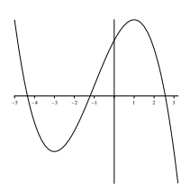

One of the six graphs below is the graph of . Circle the graph of .

